**React JS Lab**

.

**Day 1**

**LAB**

1.Create a simple calculator app by using parameterised functions.

2. Create nested elements using JSX

3. Build a starter e-commerce store for searching through products using React .Create a basic component which contains product image, specs and price.

User must be able to add products as per his convenience or remove it from the cart. (The functionalities can be achieved only through events which can be done later)

**Day 2**

**LAB**

1. Add bootstrap and other styling techniques to ensure the website is in the below format.

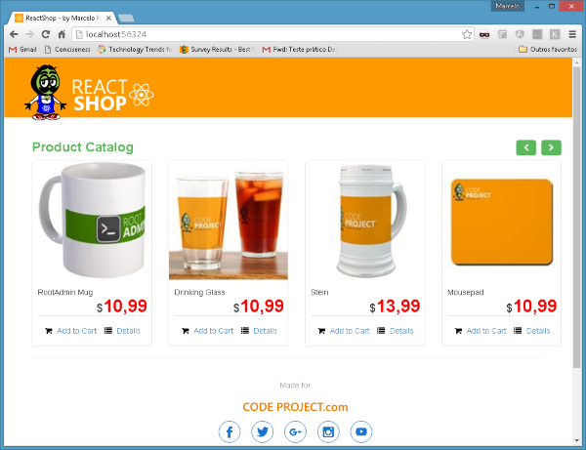

2. Use props and states to transfer data between components.

3. Try to reuse the components that have been already created.

**Day 3**

**LAB**

1. Create a simple web application to list the employees in an organization(data will be rendered from the database) and filter them based on their skill set ( ie :java ,testing,c#,bi)

2. Create a react js application to connect to display gold rates on different dates

3. Create a react js application to connect to a webservice and extract information for petrol rates at different cities on a given date.

**Day 4**

**LAB**

1.Use the existing ecommerce mobile application and provide the data to the react app using flux / redux

2. Analyse the mobile sales across the major states using bar chart.

3. Prepare a pie chart to under stand the number of mobiles with three categories ( sold , yet to be sold , with defect )